THIS VERSION IS BEING REPLACED
YOUR PATIENCE IS APPRECIATED

Terrain Editing and Painting with the Aces High Terrain Tools
AHEDIT.exe and AHOBEDIT.exe

You can create and edit terrains for Aces High using the Aces High Terrain Editor as a stand alone program to edit your height fields and paint terrain types, Or in combination with L3DT Pro, and other image editors which have other features useful in creating terrains.

Using The Aces High Editors.

Ctrl + Home keys returns to the top of this document

TE Movement Controls (navigation)

Quick Start Guide - Help for the new terrain builder
Main Arena Terrain Requirements
Conversion of Existing Terrains to AH3 terrains

Terrain Editor Menus

THE EDIT WINDOW
Checkboxes
Position
Buttons
Alt (slider)
Options
Time (slider)
Brush Size (slider)
Radio Buttons
Setting the Wire Frame Mode

THE ELEVATIONS TAB
(The Elevation setting Brushes)
The Shoreline Creation Tools

THE TERRAIN TAB
Hand painting the Terrain Types
The "Keep Current Merge Type" tool:
Painting a 512 x 512 mile terrain requires setting 16,777,216 possible 660' x 660' squares.
Painting the terrain types in a SPLAT bitmap

Terrain Setting Tools and Sliders (Everything below is waiting for contributors)

OBJECTS TAB

Man Guns
Static Objects for Immersion

Tools for finding objects in the terrain
White Squares and Red Squares

Guns
Shore Batteries
Manned Guns

Object Hardness

Setting types for nonstandard objects

Static Objects for Immersion (Not for MA terrains)
Static Rolling Stock

Enhancing your Clipboard Map

PATHS TAB

TASK GROUPS TAB

ZONES TAB

Creating a Clipboard Map (CBM)
Using the TE
Using GIMP or Photoshop

The Cloud Editor

Advanced Features
File Formats
TE File Types and Contents
The .oba file format
Searching for errors in the .oba file
The Roads, Rivers and Rail Paths file format

Creating Terrain Tile Sets for Aces High X
Prerequisites
The Strict Folder Hierarchy
The Atlas Text Files
Atlas Headers

ORIGINAL TEXT descriptions of the Atlas
Diffuse Map
Normal Map Creation
Specular Map
The Detail Map and the Clutter Map work together
Detail Map
Clutter Texture

Editing Terrains with L3DT Pro

THE OBJECT EDITOR < Pending - by Easy
1. Add trees, bushes and buildings to a terrain type tile.
2. Create "Square Tile Object" such as airfield, towns and factories.
3. Facilitate The creation of custom objects such as new buildings, runways and other useful objects.

Quick Start Guide - Help for the new terrain builder

This section is designed as a study guide toward building a working MA terrain.
TE Movement Controls (navigation)
TE Menus
Terrain Editor Windows
Navigation in the Map window
Starting a new terrain
Some Basic Definitions
Create some visible ground
Change the ground type
Change the terrain type tile set
Add Airfield, V-Base or Port
All the AH objects such as Large airfieds have a code name
Bases and their names
The Object Properties Dialog
Make a CBM for the TE
Set Spawn Points
Setting Country Ownerships
Add Town or Maproom
Strat Factories and Tank town
Add Shore Batteries
Add Task Group
Task Group Waypoints
Setting the Zones
Add Road, Rail and River
Error Checking
Do's and Don'ts
Uploading a terrain
CM Eye also know as Gods Eye
psave or .psave [optional file name <9 characters]
Main Arena Terrain Requirements

Currently (Alpha) Ctrl+S and Save As will not save your work in the TE.

Some Basic Definitions:
Brush - The red circular editing tool moved with the mouse cursor. Its size can be increased or decreased.
Path - The path used in setting beaches and roads etc.
CBM - Clipboard Map also used for the terrain editor as well as in-game.
TE - Terrain Editor
OE - Object Editor (Not for MA terrains - for advanced builders)
Terrain Type - Farm, Beach etc.
Terrain Type Tile - the aggregate of all files needed to define a Terrain Type.
Trees On - Terrain window option to show or hide the terrain types' trees.
Clutter On - The grass, plowed fields etc. at ground level in the terrain type.
Wire Frame - Used in conjunction with "Disable Ocean" to manipulate specific elevation vertices.
Snap - used to center objects like airfields, towns and strategic factories.
Strat - Strategic factories.
MA - Main Arena
Square Tile Object - Default objects such as airfields, and towns as opposed to individual objects.
myterr - often used as a placeholder for the name of the terrain, it's folder and files.
terrain folder - the folder named myterr containing all the projects files and folder. Found inside ah3terr.

Terrain Editor Windows:
The Terrain Editor consists of the main Terrain Editor window with a selection of editing options along the bottom and function Tabs along the right. In addition, a second window labeled Map will be visible unless the monitor's screen resolution has been changed recently. The Map window will contain the clipboard map (CBM) when available for use in navigation.

For navigation in the Terrain Editing window, see Movement Controls.

Navigation in the Map window:
Once a CBM is installed in the texsrc folder, the Map window can be used to drag the terrain, or zoom in with the mouse wheel. Right click on the Map window to see the available options.

Starting a new terrain (the basics for all terrains):
The folders and files for a new terrain must be created before anything will work. Launch the TE and use File>New to bring up the open dialog. Enter the new terrain name, Ex: myterr. The name must be lowercase, alpha numeric with no special characters.
As soon as Enter is pressed, a dialog box asks for the size of the terrain, the default is 512. Change it to 64 for a 64x64 mile terrain (you can change this later.) Keep in mind that setting is only the visible part, all terrains are 512x512 miles regardless of what you see in the TE or in-game.
Save and Exit the Terrain Editor.
Relaunch the Terrain Editor. The name in the title bar of the Terrain Editor window should match the name given earlier for the new terrain.

Create some visible ground:
Select the Elevations Tool Tab. Click the check box next to "(3) Set Alt." Move the mouse cursor over the Editing window. Optionally, hold the control key and roll the mouse wheel to make a larger brush. Left click and drag across the editing window. See Editing Elevations for descriptions of the elevation editing tools under the Elevations Tab.

(You may like to experiment with the Beach tool now. Later, be sure to experiment with the other tools before your start any major terrain project.)

Change the ground type:
Select the Terrain Tool Tab. The dry land created above will consist of the default terrain type, including the trees and ground clutter. To change from one terrain type to another, left click on the sample types under the Terrain Tab and use the brush to paint the dry land with the new type. See [Splat map] for short cuts in painting the entire terrain with terrain types.

Change the terrain type tile set:
Notice the Settings menu along the top of the Terrain Editing Window. A sub menu is available for Choose Tile Set. This is where you select Pacific, European, Mediterranean tile sets etc.

Add Airfield, V-Base or Port:
Make sure that the "Snap" option is set in the Terrain Window Options and then select the "Objects" function Tab.

Caution: Do not set anything in the center 1x1 mile cells of the terrain. It may work but it's likely to break someday. The center of those cells range from X=-5280, Z=-5280to X=+5280, Z=+5280.

The TE map is divided into both one mile white squares and four mile red squares, do not place more than one square tile object (field, town or strat etc.) into each red four mile square. This is mainly an issue when placing towns near to their parent airfield but also if placing V-bases close to each other, to tank town or to a strat. Also no two square tile objects should be placed in adjacent one mile squares.

Determine where the new field should be located and left click on the 1 mile by 1 mile cell in the Terrain Window.

All the AH objects such as Large airfields have a code name. For instance, a large 1 mile x 1 mile airfield is laf1m00, medium a/f is maf1m00 and small is saf1m00. You will become very familiar with all of these over time. See the scrolling objects list titled "Available shapes" under the Objects tab.

The scrolling window list of objects titled "Available shapes" is where these objects are found. The scroll bar is intuitive, however, select any object in the list and press the L key on your keyboard to automatically jump to laf1m00.

Bases and their names*:
laf1m00 Airfield Large
laf4m00 Airfield Large
maf1m00 Airfield Medium
saf1m00 Airfield Small
hq1m00 Factory HQ
aafac1m00 Factory AAA
amfact1m00 Factory AMMO
city4m00 Factory City at 4 miles square
rdfct1m00 Factory Radar
ref2m00 Factory Refinery
trptm1m00 Factory Troops
port1m00 Port at 1 mile square
town1m Town at 1 mile square
vb2m00 Vehicle Base at 2 miles square
vb1m00 Vehicle Base at 1 mile square
vbrmt Vehicle Base at 660 feet square
ttown2m00 Tank Town
flak1m00 Flak base
* All of these are referred to as "Square Tile Objects"
Also of interest
bah0 Shore battery set as BAH
cvtg0 Task Group see Task Groups for more information
mpr0 Maproom required for each Task Group

Immediately below the objects list is a button, "Add Shape/Group", click this button to add your Large Airfield. The Object Properties dialog box appears.

The Object Properties Dialog:
As soon as any airfield is added, the Object Properties dialog pops up. All square tile objects should be set as Object Type: Group Master. Notice the list box "Object Type" and scroll to Group Master and select it. The first field you set already shows the properties Field 1, Zone 1, "Can Collide" and "Set to Terrain Alt." This is all that's need for field 1 but note that under the label "Ownership", the "Field Owned" check box is checked.

Field number 1 is special. It must be Bishop and in Zone 1. The rest may be numbered according to the builders design.

Set another field and in the Field text box, change it to 2 for airfield 2. This is how to change the field numbers.
Zone 1 must be Bish, country 1, zone 2 is always for country 2 Knit, and zone 3 is always country 3 Rook.
At any time, you may edit a field's properties. Select your field with a left click plus drag and then see its object code name in the Selection List box. Highlight the field's code and double click it to bring the Object Properties dialog back on screen.

Don't worry about the rest of the options for now.

Click OK. This is a good time to notice the code description for the field as shown in the Selection List. Field 1 will read F01GMS000. That's Field 1, F01, Group Master, GMS, and the first object at field one, 000. It's a zero based numbering system. When you set a town for field 1, it will code as F01GMS001.

Suppose you want a Vehicle base. Using the same procedure for setting a large airfield, set a vb1m00. When the properties dialog appears, set the field and zone numbers appropriately. Make sure that the "Can Collide" and "Set to Terrain Alt" check boxes are set and then look for the "Object Data" text box. Set the "Object Data" field to 1 for a V-base (or 2 for a Port) and click OK. The data field determines the CBM icon for this base. Here's the full list:
0 - Airfield (this is the default)
1 - Vehicle base
2 - Port
3 - (not used any longer) Depot
4 - Flack Base

Make a CBM for the TE:
Now that there is some dry land and at least one field, it's time to create a CBM. The Terrain Editor will automatically generate a very nice CBM under File>Make Map. That will call up a new dialog box.
Set the Bitmap size to either 1024 or 2048. Leave the other options as is and click OK.
Save your work and exit the TE.

To make the CBM show in the Terrain Editor's Map window, it must be renamed and moved into the texsrc folder inside your myterr folder.
Navigate the (MS Window's) file system until you locate the map.bmp and rename it. The texsrc folder will also be inside the same myterr folder. Drag and drop your newly named bitmap into the texsrc folder.

When the TE is relaunched, the new CBM will show in the Map window and it will also show when the terrain is built.
Note: Some Windows systems may have "Show common file extension" turned off and you won't see the .bmp extension.

Notes:
The TE, and the game will recognize and use the CBM the TE generates but it's an RGB+alpha bitmap. Compared to an indexed color bitmap, it's 4 times larger and should NOT be uploaded to the server. Instead, reduce the color depth to Indexed Color which cuts the size of any CBM to 1/4 the RGB version.
Although a player shouldn't be using 512 texture sizes to play AH, but someone wishing to review or demonstrate the game on a laptop won't be able to read the sector lines or text. Each pixel he sees at a 512 texture video setting will represent a 4x4 pixel square in a 2048 CBM. SEE Creating a Clipboard Map (CBM) for details.

SEE: Enhancing your Clipboard Map

Set Spawn Points:
The "entpnt" object in the list of Available shapes is the familiar Spawn Point object. For placing these, it's best to un-check "Snap" in the Terrain Window Options. Select the location for your Spawn point with a left click and then "Add Shape/Group". The familiar Object Properties dialog box appears. Set the Object Type to "Veh Ent" for a GV spawn point. Make sure the Field and Zone numbers match the spawn points owning field. Try to avoid placing spawn points on steep slopes, partly in water or within range of a field's AA (approx 1.5 miles).

Also make sure that you un-check the "Can Collide" check box or your GV will bounce when you use the spawn point. Follow the same procedure for PT boat spawns but they are "Object Type" "Boat Entry".

Once the properties are set, select the spawn point and rotate it for the proper spawn direction according to the directions on the in-game Kneeboard. So for example a spawn point from field 20 that has its arrow rotated to face north-east in the TE will then appear to a player in field 20's tower as the top right spawn button.

To set an air spawn, the procedure is slightly different. Large airfields have no available spawn directions so use a small airfield or v-base. Set the entry point, and rotate it into an available direction for the owning base. Only then can you set the "Y:" altitude in the "Position" options and the "Object Type" to "Ftr Entry" for a fighter spawn or "Bomb Ent" for a bomber spawn.

Setting Country Ownerships:
After setting many fields, it is very common that they won't belong to the intended countries. The Settings menu has a sub menu to correct this.
Settings>Field Setup launches a dialog box similar to that used by CMs to set field ownership and vehicle availability.
Select the field(s) that have the incorrect country set and reset them using the Original Country buttons.
Be sure to save your work but be aware that zone numbers must match for each country.

Add Town or Maproom:
Each one mile square MA airfield must have a town placed nearby. But a quick terrain for private use requires only a Maproom at each airfield. V-Bases, Ports and the four mile square Airfield with a built-in town have their own Maprooms and so don't need a separate town.

Following the same familiar procedure, set a "town1m". When the Properties dialog appears, match the field and zone numbers of the owning airfield. Set the town as a "Group Master", "Can Collide" and "Set to Terrain Alt".
When setting a "mpr0" Maproom instead of a town, (never do both), set the Type as Map Room in the Properties dialog and confirm the field and zone ownership.
For the "mpr0", it is important to un-check "Can Collide" or anyone firing bullets at your Maproom will capture the base without using troops.

Strat Factories and Tank town:
These are country owned so after setting them in the terrain, their Properties dialog box require the Ownership check box titled "Field Owned" to be un-checked.
After "Field Owned" is un-checked, the label at "Field" previously used for field numbers changes. Now it will read, "Country". The Country assignments are Bish 1, Knit 2, and Rook 3.
Although it may not be intuitive, all factories are set as Group Masters. Here's the list:

These are set as Group Masters:
hq1m00 - Headquarters
aafac1m00 - AAA Factory
amfact1m00 - Ammo Factory
city4m00 - City (4x4 miles)
rdfct1m00 - Radar Factory
ref2m00 - Refinery (2x2 miles)
trptm1m00 - Troop Factory
ttown2m00 - Tank Town (2x2 miles)

Add Shore Batteries:
The Shore Battery shape is "bah0". Place it near enough to the owning base to show up in the hanger when selecting guns. Rotate it so it can cover the sea approaches to the field.
In the Properties dialog, set the Object Type to Hard Gun Bat. That sets the 4K hardness. Set "Can Collide" and "Set to Terrain Alt". Make sure it's Field Owned with the proper field and zone numbers.

Additional manned ack are shape "bas0" and need to be set as "Gun Bat Soft". These are not allowed as extras in an MA terrain.

Add Task Group:
Task Groups are pre-assembled ship fleets in a Group object named "cvtg0" but they require a land based owning Port in the MA to avoid player confusion. Alternately, some other land based field could be used for non-MA use.
They also require a Maproom placed in an out of the way spot, preferably on water, and Waypoints.

Click in the Terrain Editor window at the location for the new Task Group. If you haven't already, select "cvtg0" in the "Shape groups" list, select it and Click the "Add Shape/Group" button.

A "Select Field" dialog appears. Under "Field" scroll down and select "New". The "New" text will be preceded by the next available field number. Confirm the zone and click OK.

Task Groups must be owned by a land based field, usually by a Port. When the port or other base is captured by an enemy, then followed by the sinking of the CV, the Task Group should be owned by the country that captured the home port when the Task Group respawns.

To accomplish this, find the CV, F##SHP000, and double click its code in the "Selection List" box. In the "Object Properties" window, set the "Object Data" field to the port number that owns this Task Group, then click OK.

Lastly, find an out of the way spot to set the "mpr0" Maproom for this TG so that the CBM icon won't be noticed in-game. It's Object Type is Map Room, un-check "Can Collide", check "Set to Terrain Alt" and fill in the "Field number for the TG and Zone.

Task Group Waypoints:
All TGs must have waypoints. In the Terrain Editor Window, select the Task Groups Tab. Your new TG will show in TG list, select it. The Terrain Editor window will immediately jump to your TG.. This is handy for finding any TG.
The familiar option buttons for Looped or Patrol are available. Leave Looped selected for this exercise, then click the "Add Point". Notice that the Waypoints are placed in the Terrain Editing window instead of the CBM.
Grab the end of the waypoint path and drag it to the desired location. Add another waypoint and drag the end point and notice what happens to the "Loop". All the waypoints can be dragged with shift or ctrl clicking. You may add more waypoints for this TG but save before adding waypoints for another TG.

Setting the Zones:
Pending
At the time of this writing, Field ownership is set in the Field Setup dialog under the Settings menu and the Zone settings for Zones 1,2 and 3 are automatically adjust for everything owned by the field when its country ownership is changed.

The HQs for each country are automatically set as the country Zone Masters.

Nothing further can be said until the TE is finalized.

Add Road, Rail and River:
Pending
Roads, Rivers and Railroads are set under the "Paths" Tab.
Currently, rivers are the most complete path, but none of the paths show in-game at this time.
There were distance requirements between roads and railroad tracks because of the gun cars and collision detection.

Error Checking:
Error checking is available under File>Check for Errors, or under the "Objects" tab, clicking the "Obj Report" button. The "Obj Report" has more information and the option to save the reports. Click the "Check Terrain" button or the "Save Full Report" button.

Do's and Don'ts:
Check for errors often with File>Check for Errors.
Build your terrain and "fly" it in CM Eye often.
Learn to read the .oba file. Many errors can be caught there that may not show elsewhere.
Do not upload any test terrain to the server. Reserve uploads for a useable terrain with its final name.
Before uploading or submitting a terrain, test it thoroughly, first in the TE, then in offline mode.
Fly your terrain checking for blends between terrain types and look for hanging Square tile Objects.
Pay particular attention to the rotation of vehicle spawn points. View them in the TE and oba file.
Insure that Vehicle spawns are in reasonable places, not at the bottom of a hole or on a cliff.
If building an MA terrain, search the TE forum on the BBS for HTC sanctioned (stickied) criteria.
Before beginning serious work with the TE on an MA terrain, send a drawing and description of the terrain to HTC for their consideration. Posting these in the TE forum on the BBS would be a good idea too. The drawing should include all bases and factory layouts.

Uploading a terrain:

Final Reminder: It is a major faux pas to upload a terrain named "test" or anything similar. Wait for the final version.
When uploading a terrain to the server, only do so with the intended final terrain name. (Skuzzy will appreciate not being required to clean up after you.) This isn't meant to say you should never upload a terrain not intended for the MA or an Events arena. Custom terrains for Squad or an events' Group practice are beneficial in the Player arenas and provide experience for terrain builders. Please keep the same terrain name for all your terrain uploads. Also, please start your special purpose terrain name with the letter 'z' so that it will be at the bottom of the terrain list such as z[squadname] or z[gameID]. The CMs and AvA staff will appreciate this.

CM Eye also know as Gods Eye:
The most indispensable TE tool is CM Eye. "Fly" the terrain often.
In offline game mode, F5 will toggle CM Eye. On the server, it usually toggles a simple outside view referred to as "View Mode Fixed".
Set up a "CM Eye Move Forward" button on your joystick.
Set up a "CM Eye Move Back" button on your joystick.
Set up a "CM Eye Move Map" button or alternately, a key on your keyboard.

Use CMEye from the Tower, the Hanger or the O'Club. Hit F5.
Press the button you set for CM Eye Move Forward and move/increase your throttle forward.
Use the joystick and rudder to "fly" the terrain. If you don't have rudder, you may like Move Map better.

CMEye Move Map gives a fixed Altitude view looking straight down at the ground. You can judge your alt using the drones which fly around in circles at 3,000 feet, the same as 1,000 yards alt.
Hold down your "CM Eye Move Map" button or key, and with the throttle at maximum, move the joystick right, left, forward or back. Adjust your throttle to taste.

psave or .psave [optional file name <=8 characters]
The psave dot command saves your current position and view in CMEye. If you do not provide a file name, every subsequent time CMEye is activated, it will start in that position even if on a different terrain and off-map. The default file name, and the view that CMEye will autoload is cmepos.txt found inside the settings folder.

Main Arena Terrain Requirements

This is not an all-inclusive list. Check the Terrain Editor forum on the Hitech Creations website for updates.

Every Main Arena (MA) terrain should be equally balanced for each side with no side reaping any significant advantage through a single base capture. Do Not invest too much time into an MA terrain before submitting details and images of the bases and factory layouts to Hitech Creations for approval. This will save frustration later. Be patient and give them a few weeks to review your designs before you call them. If this is your very first terrain, do not be surprised if it is rejected.

Terrain sizes for an MA terrain must be either 256x256 miles or 512x512 miles. Keep in mind that is only the visible part, all terrains are 512x512 miles regardless of what you see in the TE or in-game.
No custom objects of any kind are allowed.
Currently, no custom Terrain Type Textures and Tiles are allowed.

Field Locations:
Airfields -
Airfields should be no closer then 3/4 sector, or about 19 miles apart,
Airfields should be no further then about 25 miles apart.

Vehicle Bases -
Vehicle Bases should be at least 8 miles from airfields and Ports and at least 3 miles from another Vehicle base.

Flak Bases -
Normally, two Flak Bases are set at two miles from the HQ and City, one on each side.

Ports -
Ports should be no closer then 8 miles to the nearest vehicle base and between 13 and 25 miles to the nearest Airfield.

Strat -
Strategic facilities (HQ, city, factories) should be at least 8 miles from airfields and at least 3 miles from a Vehicle base.

Spawn points -
Spawn points from other bases should be at least 1.75 miles from the edge of the nearest square tile object (bases, towns, strats etc. but not tank town). This is to ensure that no one spawning there can come immediately under fire from an AA gun. (This minimum distance may also need to be made greater for game play reasons). The standard distance from the target base in AH3 is three miles, down from 5 in AH2.
Land or sea spawn points should be placed so they are entirely on land or water respectively.

No two square tile objects may be placed within the same red 4 mile square in the TE. No square tile objects may be placed next to each other unless both square tile objects are perfectly flat at all edges.

Tank town should be placed at least one mile from the nearest base (i.e. not touching).

All capturable bases should have a capture path. Either a nearby airfield or V base, spawn points into the base, or access for a CV group.

Conversion of Existing Terrains to AH3 terrains
Conversion of Existing Terrains to AH3 terrains:
1. Open the Aces High Terrain editor and Choose "File" > "Convert 2.0 Terrain."
2. Select the directory of the old terrain that you want to convert. Click "OK" and the conversion begins.
Do not put the original terrain in the ah3terr folder.

The new files will be written to a sub folder underneath the AH3TERR folder in your Aces High installation directory.

TE Movement Controls (navigation)

Movement Controls:
Note : All of the Aces High editors use the same controls:
W – Move Forward
A – Move Left
S – Move Right
D – Move Back
Q – Move up
Z – Move down

Right Mouse Button + Mouse - View Direction
Mouse Wheel – Move Speed (when used in combination with movement keys)
Left Mouse Button – activates current tool
Shift + Mouse wheel – changes current tool parameters
Ctrl + Mouse Wheel – changes current tools brush size
Shift + Left Mouse Button – Modifier for use on lowering / rising points

CTRL + Z – undo (no redo available)

Terrain Editor Menus

File
New... Create a new terrain (the source files - remember to save)
Open... Open an existing terrain's source files
Save Save an existing terrain's source files (note Ctrl+S doesn't work)
Save As... Save an existing terrain under a new name
-------
Export... Export both versions of the height map and the splat map
Import Signed Height Map Import a signed 16 bit x 4096 x 4096 .raw height map
Import UnSigned Height Map Import an unsigned 16 bit x 4096 x 4096 .raw height map
Import Splat Map Import an RGB formatted 4096 terrain type map
Convert V2.0 Terrain Imports a terrain created with the AH2 terrain editor
Make Map Creates a Clipboard Map (CBM)
-------
Level terrain on square objects Globally levels bases, towns and factories after installing one of the dot raw heightmaps. (SEE Objects Tab)
Set All Tiles to Terrain Height Globally matches the terrain verts to bases, towns and factories after converting an AH2 terrain.
-------
Check For Errors One of two available methods to check the terrain for errors
Build Create the terrain res file
-------
Exit

Settings
Fields Setup Dialog for setting country ownership of fields and default planeset. Be sure to have the Zone Tab open to coordinate country and zone.
Terrain Settings Change map size, world location, time zone and date
Field Capture Order Set or late game capture order or force uncapturable fields, i.e. a closed loop to prevent a reset
Choose Tile Set Set European, Pacific, etc. for the default terrain tiles types

Help
Web Help
About The current version of the TE and the Copyright notice

THE EDIT WINDOW

Checkboxes
Grid Toggles the 1 x 1 mile white grid along with the 4 x 4 mile red grid.
Trees On A toggle that hides trees, the default is off.
Snap Used to center objects in a 1 x 1 mile cell.
Wire Frame¹ Toggles the wire frame mode but requires Disable Ocean & Time adjustment.
Clutter On Toggles grass and rocks.
Disable Ocean A Toggle that hides blue water, required for Wire Frame viewing.

Position
X The East/West location in feet
Y The elevation above or below zero sea level
Z The North/South location in feet

Buttons
Top View: Just what it says, look down on the terrain
Home View: Relocate to the Home location in the center of the terrain when lost
Save View: Saves your place in the terrain for returning to a previous work location
Load View: Load a saved location in the terrain

Alt (slider)
Changes the viewing altitude. The W and S key do the same after the Top View Button

Options
Auto Save Checkbox: May protect the terrain from disaster along with the Minutes Textbox, however, if testing, you probably don't want to save over your terrain.
Minutes Textbox: The delay between saves.

Time (slider)
Changes the lighting. Useful for CBMs and Wire Frame views

Brush Size (slider)
The Brush is the common tool used to set elevations and ground type,
Changing the size of the brush changes the area the action effects.

Radio Buttons (used with the Terrain type Tab)
Solid Brush Use only the primary terrain type
75% Brush Mix² the primary type with the secondary type. Useful to break repeating patterns.
50% Brush
25% Brush

¹Setting the Wire Frame Mode
The Wire Frame ability is very useful for tweaking the elevation at individual vertices on land. At this writing, it doesn't work for elevations under water. Set the Disable Ocean checkbox along with the Wire Frame checkbox. Then, to bring the wire frame into contrast, slide the Time slider to the top and adjust downward as necessary. It helps sometimes to uncheck the Grid.
²Avoid combinations with intervening bands of texture.

THE ELEVATIONS TAB

Elevations are relatively simple to to edit in AHEDIT. Click on the Elevations Tab in the editor and you will see a list of Brush types you can use on your terrain. The different Elevation tools can be activated with a keyboard shortcut. Type a 3 to change to the Altitude Brush or a 7 to change to the Beach Brush. Be careful if you're multitasking, the brush may change unexpectedly.

Brush types 1 & 2 are smoothing algorithms that you use to smooth out rough spots on your terrain. You can use which ever you like that suits your preferences.

Brush 3 is a basic set terrain altitude brush which will set the terrain to whatever altitude you set the parameter too

Brush 4 and 5 are both raise / lower tools. Left click to raise the altitude, Shift + Left Mouse Button to lower the elevation

Brush 6 is a bulldozer tool to slope the terrain between two points. Work from the low point to the high point to maintain the width of the brush. Click on one point of the terrain and then drag the mouse to where you want the bulldoze to end. When you release the mouse button, the terrain will be sloped between the two points.

The Shoreline Creation Tools

Brush 7 is a beach creation / smoothing tool. To use this tool, press the "Spline all islands" button and splines will be generated at and around all water / land boundaries, From here you have the option to hand paint with the brush, or press "Create all Beaches" and the program will do it for you.

Hand Painting Beaches (two methods)
If the "Spline all Islands" tool was used, and manual painting is desired, every blue beach line must be painted to create the beaches. This isn't that bad, even in a large terrain if there aren't too many islands. Adjust the brush cursor to a suitable size and paint the beaches by hand. The disadvantage to this is that the beach line can not be moved.

The beaches can be drawn manually with much more control. Clear any current beach paths with the Clear button. Use Shift Left click to set the first point of the path and all points thereafter. Note that the blue line of the beach path has arrows pointing toward dry land. If the arrows point out into the water, then clear the beach path and start setting the points in the opposite direction. It will help to be consistent whenever setting paths for the beaches.
Shift Click sets the points and Ctrl + Click and Drag moves them.
The maximum safe number of hand painted beach points is 256 points.

THE TERRAIN TAB

Hand painting the Terrain Types:
No terrain will look its best unless the builder does some hand application of the Terrain Types, but to do that some basic knowledge of the Terrain Type system is necessary.

Each Terrain Type Tile carries a ground texture, the trees, bushes and sometimes a few random buildings. Each type will also include "ground clutter" in the form of waving grass, weeds, farm crops, plowed fields etc. The texture and objects in any given Terrain Type are constant for that type.

Definition: Terrain Type Tile or simply tile, is the aggregate of all the components that make up a terrain type tile.

Background:
Terrain Types are made in complete sets called Atlases of 20 terrain types. In the TE, it's clear that the upper four Terrain Types are larger then the lower 16 Terrain Types. The difference is a 1008 x 1008 pixel bitmap for the upper four types, and a 504 x 504 pixel size for the bitmaps used in the lower 16 types. The larger tiles are often referred to as "bigger" or "larger" as opposed to the "smaller" types.

Also, the Terrain Type Tiles have a sequence, Atlas 0 Types 0 to 15 and
Atlas 1 Types 16 to 19.

Worth noting here is that the terrain types for an entire terrain may be set by painting in a graphics program using RGB values in a bitmap referred to as a Splat Map.
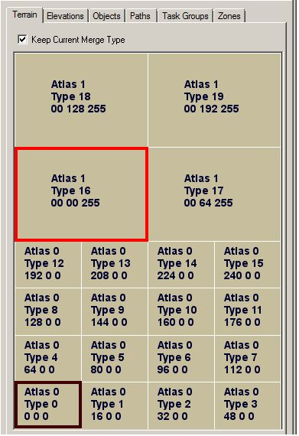

A 660' square (sometimes called a pixel) is the smallest bit of a texture that can be drawn, and the texture will bleed-blend or clash into some of the surrounding 660' spaces at the borders, depending on the color, pattern, and in what order the types are laid down.

The Terrain Types are drawn in sequence even if none are wanted between two Types. They are designed to be laid down in sequence without skipping types in the sequence, or with the fewest number of sequence jumps. By that, Type 1 is meant to be next to type 0, type 2 is meant to be next to type 1 and so on. This is because a bleed/blending line occurs for each intervening terrain type between any two adjoining terrain types. A type 12 Terrain Type next to a type 2 Terrain Type will have 9 intervening bands, one for each Terrain Type between types 2 and 12. This situation can be ugly and should be avoided by the Terrain Builder, and the "Filter Tool" is included in the TE to help.
The "Keep Current Merge Type" tool:

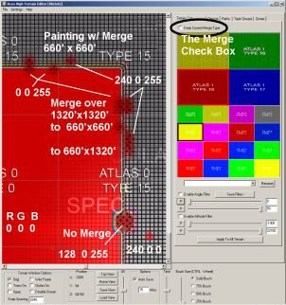
The Keep Current Merge Type Check Box:
This tool can force a blend that eliminates the texture banding clash between two textures that are placed "out of the type sequence."

Study the image on the left to see the tool's resulting application.

The Red Type is Atlas 0 Type 0 and the other is Atlas 0 Type 15. Without adjustment, there are normally 14 intervening bands of texture between these two types.

By using the Merge tool and selecting Atlas 1 Type 16, you'll achieve the best blend by painting over the two banding rows. However, if you choose Atlas 1 Type 19, the three Atlas 1 bands, 15 to 18 will show.
(The RGB values are provided for Splat Maps.)

Using the same technique, the banding between two Atlas 1 types can be hidden, but it requires a little more work.
If Atlas 1 Type 16 is on the left, and Atlas 1 Type 19 is on the right, there are normally 2 bands for type 17 and 18 between them. This band can be hidden in a similar way with the Merge Type tool and it requires only a single 660' square, or row to achieve.
Select the matching type for the lower type number, Atlas 1 Type 16 in this example. Then select the best blending match from the Atlas 0 types as the primary type. With the Merge check box set, Atlas 1 Type 16 is the secondary type with a black rectangle around it, and the primary type from Atlas 0 is surrounded by a red rectangle.

Paint over the banding in the current Atlas 1 Type 16 with the smallest brush size and watch the banding replaced by the Atlas 0 type. If painting over the higher type number, some degree of banding will remain.

Suppose that most of the terrain is previously painted with Atlas 0 Type 8 and a farm or village from Atlas 1 type 18 is desired.
Paint the area where the village is desired with Atlas 1 Type 18, the clashing banding will appear.
Then go back and paint the clashing border, or bands, using Atlas 1 Type 16, with or without the Merge tool active. The banding will disappear.

Painting a 512 x 512 mile terrain requires setting 16,777,216 possible 660' x 660' squares.

Obviously, the terrain builder shouldn't try to paint all of these by hand but judicial effort in high traffic areas, such as around bases, will pay in a better looking terrain.

Terrain Setting "Filter" Tools and Sliders:

- Subject to Change -

Caution:
Save often! Currently there is no undo and you can easily paint your whole terrain with a single ground type. Be sure to use the 'Enable Alt and/or Angle Filter' check boxes.

At the bottom of the Terrain Tab are a group of sliders and text boxes. The image below illustrates painting an entire terrain with eleven terrain types at one thousand feet intervals and painting the cliff face in the foreground with Snow.
By selecting a terrain type, such as Beach, Atlas 0 Type 0, and entering a Low Altitude and High Altitude, you can automatically paint an entire terrain between the Low and High Altitudes with Beach.

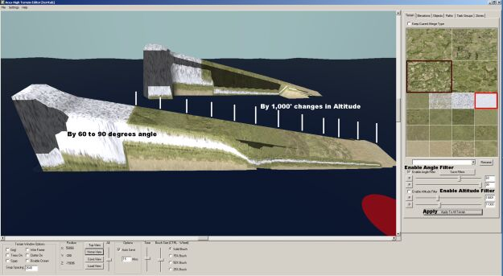

The buttons labeled P are for grabbing altitudes or angles directly from the terrain. The first step is to set the appropriate Enable check box. Press the appropriate P button and then click on the terrain to gather the angle or elevation data.

It's very important to uncheck any filter you are not using as there is no undo and both filters can be engaged at the same time.

Painting the terrain types in a SPLAT bitmap:

In addition to the Terrain Tab in the TE, the TE facilitates export/import of all terrain type assignments in a terrain. The texture type file (now called splat) is exported into a 32 bit bmp
Under the File menu, Export will create and export a filed (re)named splat.bmp along with the .raw files.
The splat.bmp will be placed inside your main terrain folder. It's a good idea to rename these files so they won't be overwritten and as the TE allows you to browse to the desired version.

The Splat map is another 4096x4096 bitmap. Each RGB pixel represents a square in the terrain that is 660'x660'.

The color mapping is as follows:
The R channel defines the small texture type. (0 = type 0, 16 = type 1, 32 = type 2 ... type 15)
The G channel defines the Large texture type (0 = 0,64 = 1, 128 = 2 192 = type 3)
The B channel is a blend factor between the 2 types, this is normally always 0 or 255 for no blend.
The R channel will typically read R,0,0 where R defines the unblended terrain type.
The G channel will typically read 0,G,255, where G defines the unblended terrain type.

The same cautions for artifacts between adjoining types apply in the Splat map as apply in the TE under the Terrain Tab. The images below illustrate the blending ability of a Splat map.

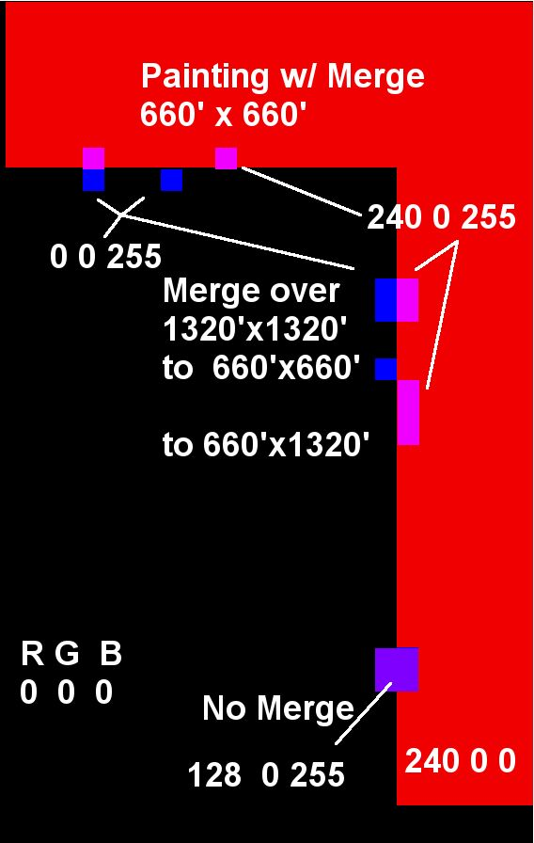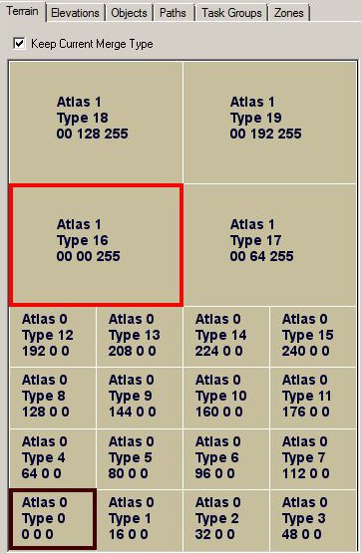

SEE the text above. It may be necessary to experiment with this technique to understand the requirements.

OBJECTS TAB

The Objects Tab is divided into three sections: buttons that provide commands or functions, the list of shapes available to include in a terrain, and tools below the Selection List for finding objects after they've been installed in the terrain.

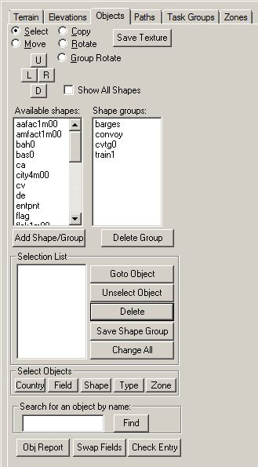

The radio buttons at the top of the tab window are self explanatory.

Push buttons U, D, L, and R rotate Square Tile objects to precise 90 degree increments. Use these buttons for Ports, entry points, etc.

The Save Textures button will export all the textures for the shape in the Available shapes list. A new 'savedtex' folder will be created in the current terrain project's folder.

Check box Show All Shapes will unhide the less used shapes in the Available Shapes List Box

Available Shapes lists the default shapes commonly used in Aces High. The list can be expanded to include all shapes by using the Check Box for Show All Shapes.

The Shape Groups list is primarily used to place Task Groups but custom groups can be added. The default list also includes the rolling stock for roads, rivers and railroads.

The Delete Group Button should not be used carelessly. The default groups needed by the TE include barges, convoy, cvtg0, and train1.

The Save Shape Group button will group objects placed in the edit window and create a custom group of objects. This might be useful for gathering all the train and truck objects, or a group of all GVs. The group names are up to 8 characters long and should not be similar to any of the default group names needed by the TE.

Stopped update here

Items above the Selection List Label

Items below the Selection List Label
Items seen in the List Box of Selected Shapes can be double clicked to bring up their Properties dialog.
Single clicking an item in the Selection List will select it for action by the Buttons along the right side of the list box.
Push Buttons
Goto Object - centers the Edit window on the highlighted object in the list box
Unselect Object - removes the highlighted object from the list box
Delete - deletes the highlighted object from the terrain
Save Shape Group - creates a new Shapes group to include all the objects in the Selection List
Change All - allows for certain properties to be changed for the selected group of objects. The properties that can be changed are the Object Type, Object Data, or the object’s owning country or field, and Zone number.

Tools for finding objects in the terrain

Select Objects (See the image below)
Country push button - will display all the factories owned by the country.
Field button - displays all the objects owned by a particular field
The Shape button - will find all the objects of a given shape name
The Type button - will find all the objects of a given type, i.e. Ftr Entry when not part of a square tile
The Zone button - disabled

In the text box, "Search for an object by name", you can recreate the object's text name and find it that way.

The bottom three push buttons aid in finding errors.
Obj Report - produces a verbose list of errors in a dialog window with several other features
Swap Fields - allows the field numbers for two fields to be swapped

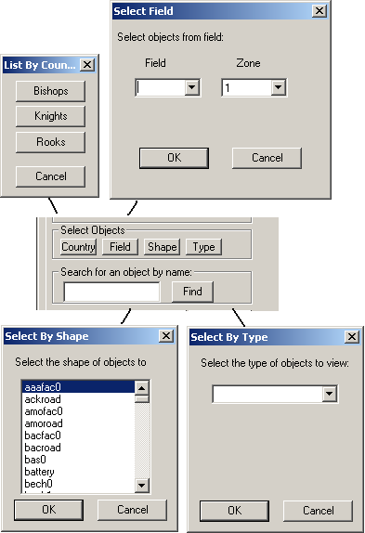

White Squares and Red Squares

Each White square is one mile by one mile. Crossing vertically and horizontally at center of the home position (x=2048, y=2047) are two red lines. These lines are repeated every four miles both vertically and horizontally and form 4x4 squares. A 4x4 square tile object must fit within the lines. With the Snap checkbox set, the TE will center the 4x4 square tile object in whichever red square that you drop them.

Man Guns

It's best to Place AI ack in the Object Editor but they can be placed in the TE
gng0 for 88mm Flack
gng1 for 37mm ack
gng2 for quad 20mm
Set the properties as Auto Gun for all three.

Shore Batteries:
Man guns include Shore Batteries, bah0. They are normally place in the TE with the property set as Hard Gun Bat. That sets the four thousand pounds of hardness. Set "Can Collide."
For non-MA terrains, Shore Batteries can be recessed into the terrain.

Manned Guns:
(The following gun additions are not allowed in an MA terrain.)
The standard manned ack at this writing is bas0 and needs to be set as "Gun Bat Soft". Install in either the TE or OE.

Set all of these manned guns as "Gun Bat Soft".
bas0 the 37mm manned gun
17pdr the 17lb manned gun
88emp0 88mm manned gun
If a new manned gun is added, it will probably require the same settings.

Object Hardness
Object hardness should remain at the default for all standard objects. Otherwise it causes confusion for the players and it can be adjusted in the Arena Settings for special events. For nonstandard objects, the following is provided.
In the past versions of the TE, the conversion factor was 6.4 points of damage per pound. To set a custom hardness in the TE, multiple the desired explosive power or hardness, say 2,200 lbs x 6.4 = 14,080 points. That object will require 2,200 lbs of bombs or its equivilent.

Setting types for nonstandard objects:

Barrier = can not be damaged.
Structure = both sides can damage
Void = enemy can damage.

Static Objects for Immersion (Not for MA terrains)

Occasionally, it's nice to add details to make a square tile object look more alive even though the additions are fixed in place. Hence these aids for adding static aircraft, vehicles and rolling stock. The list of aircraft heights and pitch were provided by Hitech to bustr in a forum post. The list of vehicles is subject to change.

p51d Height 6.80 Pitch = 0.2583
109k4 Height 4.46 Pitch = 0.2112
spit9 Height 4.96 Pitch = 0.2204
b17g Height 7.90 Pitch = 0.1007
c47a Height 10.35 Pitch = 0.1644
la5fn Height 5.40 Pitch = 0.2470
n1k2 Height 5.57 Pitch = 0.2269
190a8 Height 6.42 Pitch = 0.2477
c205 Height 5.42 Pitch = 0.2583
f4u1d Height 6.20 Pitch = 0.2391
b26b Height 6.30 Pitch = 0.0689
109f4 Height 4.57 Pitch = 0.2112
109g2 Height 4.46 Pitch = 0.2133
109g6 Height 4.50 Pitch = 0.2224
f4u1c Height 6.20 Pitch = 0.2391
spit5 Height 5.06 Pitch = 0.2321
p38l Height 5.91 Pitch = 0.1204
c202 Height 5.45 Pitch = 0.2592
m16 Height 3.25 Pitch = 0.0000
typhoon Height 6.60 Pitch = 0.1920
panzr4h Height 4.25 Pitch = 0.0000
190a5 Height 6.42 Pitch = 0.2477
yak9u Height 5.55 Pitch = 0.2190
a6m5b Height 5.15 Pitch = 0.2199
m3 Height 3.25 Pitch = 0.0000
p47d40 Height 6.30 Pitch = 0.1868
p47d25 Height 6.30 Pitch = 0.1868
ostwind Height 4.25 Pitch = 0.0000
ju88a4 Height 6.25 Pitch = 0.1798
lanc3 Height 9.51 Pitch = 0.1246
f6f5 Height 6.52 Pitch = 0.2129
tbm3 Height 6.83 Pitch = 0.1693
ptboat Height 0.00 Pitch = 0.0000
drunksl Height 0.00 Pitch = 0.0000
seafire Height 5.06 Pitch = 0.2314
tempest Height 6.60 Pitch = 0.1920
ar234 Height 4.74 Pitch = 0.0257
ta152h Height 7.20 Pitch = 0.1745
190f8 Height 6.42 Pitch = 0.2477
la7 Height 5.40 Pitch = 0.2470
yak9t Height 5.55 Pitch = 0.2189
190d9 Height 6.40 Pitch = 0.2251
p51b Height 5.83 Pitch = 0.2077
p47d11 Height 6.30 Pitch = 0.1868
ki611c Height 5.10 Pitch = 0.2094
lvta4 Height 0.00 Pitch = 0.0000
lvta2 Height 0.00 Pitch = 0.0000
il23 Height 6.20 Pitch = 0.1920
me262 Height 5.46 Pitch = 0.0000
m8 Height 3.86 Pitch = 0.0000
f4u1 Height 6.20 Pitch = 0.2391
f4u4 Height 6.20 Pitch = 0.2391
hurri2c Height 6.63 Pitch = 0.1789
hurri2d Height 6.63 Pitch = 0.1789
mossie6 Height 6.63 Pitch = 0.1979
ki67 Height 7.11 Pitch = 0.0960
110c4 Height 6.51 Pitch = 0.1730
spit1 Height 4.85 Pitch = 0.2112
109e4 Height 4.80 Pitch = 0.2496
hurri1 Height 6.70 Pitch = 0.1780
110g2 Height 6.51 Pitch = 0.1730
spit14 Height 5.18 Pitch = 0.2471
boston3 Height 6.80 Pitch = 0.0353
f4f4 Height 5.00 Pitch = 0.1833
fm2 Height 5.00 Pitch = 0.1833
a20g Height 6.80 Pitch = 0.0353
d3a1 Height 5.70 Pitch = 0.2007
sbd5 Height 5.40 Pitch = 0.2227
a6m2 Height 5.12 Pitch = 0.2166
p40e Height 5.50 Pitch = 0.2171
p40c Height 4.97 Pitch = 0.2147
me163 Height 4.25 Pitch = 0.1309
tiger1 Height 4.48 Pitch = 0.0000
ju87d3 Height 6.70 Pitch = 0.2077
b5n2 Height 6.42 Pitch = 0.2087
ki84 Height 5.13 Pitch = 0.1868
b24j Height 8.90 Pitch = 0.0361
t341943 Height 2.95 Pitch = 0.0000
p38g Height 5.91 Pitch = 0.1204
p38j Height 5.91 Pitch = 0.1204
p47n Height 6.30 Pitch = 0.1868
109g14 Height 4.50 Pitch = 0.2171
spit8 Height 4.87 Pitch = 0.2204
spit16 Height 4.88 Pitch = 0.2204
jeep Height 2.20 Pitch = 0.0000
rv8 Height 3.48 Pitch = 0.1874
f4u1a Height 6.20 Pitch = 0.2391
firefly Height 4.05 Pitch = 0.0000
b25c Height 6.90 Pitch = 0.0347
b25h Height 6.90 Pitch = 0.0347
p39d Height 5.90 Pitch = 0.0855
p39q Height 5.90 Pitch = 0.0855
wrblwnd Height 4.25 Pitch = 0.0000
sdk251 Height 2.10 Pitch = 0.0000
t3485 Height 2.95 Pitch = 0.0000
i16 Height 4.86 Pitch = 0.2651
b239 Height 5.11 Pitch = 0.2100
p47m Height 6.30 Pitch = 0.1868
dr1 Height 4.24 Pitch = 0.3128
f2b Height 4.75 Pitch = 0.1679
camel Height 4.21 Pitch = 0.2449
dvii Height 4.53 Pitch = 0.2094
m4a375 Height 4.05 Pitch = 0.0000
m4a376 Height 4.05 Pitch = 0.0000
mossi16 Height 6.63 Pitch = 0.1979
panther Height 4.63 Pitch = 0.0000
g4m1 Height 6.39 Pitch = 0.0902
b29 Height 8.23 Pitch = 0.0454
a6m3 Height 5.15 Pitch = 0.2199
tiger2 Height 4.48 Pitch = 0.0000
p40f Height 5.60 Pitch = 0.2054
panzr4f Height 4.25 Pitch = 0.0000
p40n Height 5.65 Pitch = 0.2061
m18 Height 4.05 Pitch = 0.0000
fi156 Height 5.10 Pitch = 0.1955
me410 Height 6.00 Pitch = 0.2461
ju87g2 Height 6.70 Pitch = 0.2077
seahurr Height 6.70 Pitch = 0.1780
he111 Height 6.62 Pitch = 0.1484
ki43 Height 5.20 Pitch = 0.2199
hetzer Height 2.91 Pitch = 0.0000
jgdpzr4 Height 4.43 Pitch = 0.0000
jgdpthr Height 4.44 Pitch = 0.0000
yak3 Height 5.30 Pitch = 0.2199
yak7b Height 5.50 Pitch = 0.2356
tu2s Height 6.42 Pitch = 0.1784

Static Rolling Stock
truck
blitz (a truck)
blitz1 (a truck)
blitz2 (a truck)
flakcar (both of these track the drones and can't be destroyed with .det f01str 2)
guncar (both of these track the drones and can't be destroyed with .det f01str 2)
hudson
loco
htender
tender
box1
boxcar
tanker1
tanker2
flat0
flat1
flat2
flat3
flatbed
sleeper
caboose

Creating a Clipboard Map (CBM)

Using the TE
Using GIMP or Photoshop

Hitech has advised to keep the CBM at indexed color when you upload it to server as there isn't much if any benefit to 32 bit color and it increases the res file size. We shouldn't have a problem with that and I'll include a note about it as you suggested earlier.

Converting to indexed color can be a problem for some graphics programs. AH uses the original bitmap format with a 1073 byte header. A newer bitmap format, version 5, is used in some programs, such as MS Paint and others and won't show properly in AH. AH is not alone in this as a game company, it's a quite common complaint.

Enhancing your Clipboard Map

The Terrain Editor makes a nice automatic CBM, but the builder with some artistic skill can do better.

The Artist will need a tool like Photoshop or GIMP but all the original textures will be produced by the Terrain Editor.

Remember to back up the terrain and it's preferable to use a temperary terrain for creating the CBM.

These are the textures required:
An embossed elevation texture, preferably without any ground type noise.
A ground type texture.
A water texture.
A shoreline texture (optional).
A sector grid and number textures.

Generally, these are the steps required.

Obtain the embossed elevation texture.
Paint the entire terrain with deep ocean sand and skip to the time of day lighting changes unless willing to use the custom tile method.
Create a custom, all white terrset for creating the embossed elevation file.
Install the custom terrset into your terrain folder and activate it in the TE.
Useing the time of day slider in the TE, move the light source until you see shadows for mountains etc. and then use the Make Map function without gridlines to output the result. It may be necessary to also change the location Latitude to the equator to achieve the best output. Experiment until achieving a nice embossed texture representing the elevations.

Obtain the sector lines texture and numbers texture.
Create a new terrain that is all water. Using the Make Map function, modify the text size to taste. Using the graphics program, select by color and set the range to zero or one. Select the lines, then copy and paste them into a new layer. Repeat with the sector numbers making a new layer with sector numbers only. HINT: If a single pixel of the same color as the sector numbers is placed in the upper left corner of the texture, it will be selected along with the secotor numbers and auto align the numbers with the sector grid.

Obtain the ground type texture.
Often, the TE produces a somewhat pixelated or checkerboard looking CBM due to the changing ground types. It's possible to mitigate this by reducing the texture size and with a blur function in the graphics program, but there are alternatives.
Reducing the number of ground types can reduce the pixelated appearance of the TE's Make Map output. A more difficult option is to export the Splat map and directly manipulate the colors. HINT: To reduce the color variation, temporarially convert it to gray scale and replace the grays with color.

Obtain the water texture.
Every output of the TE's Make Map function will show the water very nicely. Output a map without any grid lines. Select the water only and copy paste it into a new layer following the same procedure used with the sector numbers. If an additional shoreline layer is desired, it can be created using the water texture but won't be discussed here.

Assemble the textures into a single file.
Generally, the bottom layer will be either the embossed elevation texture or the ground type texture. These two will have varying degrees and types of transparency.
Next up will be the water layer. The color can be changed to taste and a semi transparent layer of waves can be added.
Then the shorelines if included.
The top layers will be the grid lines and sector numbers.
Such items as text or a map scale graphic can be added.

The Cloud Editor

Waiting for... well, you started it

;<))

A tip HT gave me when using the cloud editor is to use minus numbers in the "First Create HR:" box. This sets the time that cloud bank is first created to a point before you enter the terrain. That way you do not have to wait for your cloud systems to generate.

I've had no problem with frame rates and clouds either, but then I have a decent PC which runs the alpha at over 80 fps. It is hard for me to know how many clouds to include. I want them to look good but I don't know how much they will affect those players running on marginal systems.

A few things I have found out that may help other terrain builders:

For MA terrains I try to set all the cloud systems to have the same lifetime, exactly one hour in my case. That way the maximum cloud count stays the same however long the terrain runs.

If you put a number of cloud fronts together and you want them to stay together for more than one front life time they will all need to have the same number of rows and clouds per row. This is because even if they are all set to the same speed a front with more clouds takes a little longer to generate on each cycle and so will be a little further away from a smaller front than last time. Over subsequent cycles the group will gradually break up. Again this is mainly an issue for MA terrains.

The density of cloud types in the editor from lightest to heaviest goes something like: 0,1,3,7,6,5,2,9,8,4. So using 0 and 1 in a cloud bank will give lightly scattered puffs of cloud while 8 and 4 will give a heavy overcast. There is about twice as much of the max type of cloud in a bank as the min type.

Advanced Features

TE File Extensions, Types and Contents
.dsc Terrain description for the upload server
.ef The Error Checking results.
.fld field ownerships
.mdm terrain size
.oba object file (bases, strat, etc)
.pln vehicle config file
.tra track file for Paths
.wpt TG waypoint file
.raw elevation export/import file
.htx (no longer being used?) several uncompressed file types
.htz several compressed file types
splattype.bmp ground type export (always named splattype.bmp)/import (any bmp name) files

The .oba file format:
No header. Each line contains the following fields. The brackets contain the character counts including the comma where applicable.

Object_Name[16]; Fddaaa### d=decimal a=TYPE code, #=item's hex number
Object_Shape[11]; TE name i.e. hq0
X_feet[15];
Z_feet[15];
Y_feet[15];
Roll_radians[8];
Pitch_radians[8]; Use to angle aircraft's tail
Rotate_radians[8]; Your Group Masters must be 0.0000 or 1.5708 or -1.5708 or 3.1416 or their equivalent.
Flag_bits[11]; The property flags. Factory Object + Collide = 768
Field#|Country#[6]; Zero based field or country number
Object_number[6]; Object index number instead of shape name
Hardness[9] default = -1
Downtime[9] default = -1
Point_Value[11] default = -1
ID_Object_Sequence[5] 'ID' 0 based Decimal ID for gun#, truck# etc.
GroupID[6]; Not currently used (Beta 6)
Object_Data[6]; 'Object Data' VH=1 or Port=2. CV's port ownership
Zone[6]; Zero based zone number
UpdateFlag[5]; Probably still used internally.
FOLLOWED BY TWO MORE UNCOUNTED CHARACTERS 0x0D0A.
With 18 commas the total is 176 characters + the 2 char line end (0x0D0A)

Searching for errors in the .oba file:
Make a backup copy before opening the oba file and use the copy for error checking.
These first three items are the source of the most frequent errors.
Verify the rotation of all Group Masters
Compare the Flag_bits fields for all like shapes. If different, then verify in the TE
All square tile objects should be Group Masters, GMS in the Object_Name field and 36 in the Object_number field.

Look to see that all square tile objects have supply trains and convoys.
If the game throws a missing object shape text message, grab a screen shot and search the oba file.
Compare zone numbers for all intended country ownership of strat. Separately, if a reasonably small number of bases, check the zone numbrs for the bases. Otherwise, don't forget to check each base number for country and proper zone in the TE Fields setup and zone tab.

Creating Terrain Tile Sets for Aces High

Here's what you need to know right away. What you learned using the ahskview.exe won't apply here with one very important exception, the _n.bmp files. If you have the plug-in to produce them and some experience creating a normal map, you'll be ahead of most new users.

This YouTube video, if it still exists, is helpful, but there are others available too.
https://www.youtube.com/watch?v=8Jdo3ZmtPWk

The basic Aces High Terrain is comprised of textures/images selected from a tile set. Each tile set is made up of atlases. An Atlas is one large texture which is filled with many smaller images. The “Terrain Editor” comes with a number of tile sets. If you wish to create your own tile set, then this is the section you are looking for.

Don't miss Greebo's excellent AH III skin tutorial on the AH bulletin board. His description of the textures is not to be missed.

http://bbs.hitechcreations.com/smf/index.php/topic,378949.msg5045819.html#msg5045819

For clarification.
A builder can choose textures for a hybrid terrset using the default textures from the 3 terrsets that have been released, however several are used in more then one terrset so there aren't 4 full sets available. This would still be the fastest way to add variety to an AvA/SEA terrain.
Although it isn't hard to create a custom terrset, all 20 slots for the textures must be provided even if some are repeating dummy textures such as 3 or 4 identical sand tiles. Then for each ground tile type the builder wishes to use, he'll need to add the appropriate terrset trees and buildings. The limiting thing about trees, buildings and bushes is that they come in dedicated terrsets that can't be modified. Unfortunately a PAC bush can't be placed in an ETO terrset and ETO buildings can't be placed into a PAC terrset. Even the buildings in a terrain tile are fixed within the list of available shapes in any given terrset.
I will take care here to point out that the objects for terrain tiles are Speedtree objects and not the same as objects for square tile objects used in bases, towns and factories. Square tile objects can not be placed into terrain tiles.

Caution: Terrain tile textures should "tile" as much as possible. Colors, roads, tree lines, and anything else should not end abruptly at a tile edge. The diffuse textures should be from the same color pallet if possible, just as they always have been in quality texture sets.

Prerequisites:

Terrain Type - A Farm texture, Beach texture etc.
Terrain Type Tile - the aggregate of all files needed to define a Terrain Type.
(The sample files and folders discussed in this section may not be shipping with the TE)
htcterrsets folder - samples and the default terrain textures for the game.
terrset00 folder, the ETO set discussed here. SEE the similar terrset01 (PAC), or terrset02 (MTO).
spdtree folder and its subfolders will contain each terrain tile's layout for trees and building
texsrc folder (the 2nd one needed) contains the bitmaps for each terrain tile's images,
such as type1.bmp, type1_a0.bmp, type1_b1.bmp, type1_n.bmp and type1clutter.bmp
Also inside the terrset00 folder are numerous text files
atlas0.txt - This is where the game picks up the base texture name for each terrain type.
Some, but not all bitmap images use the names in this atlas or its sister atlas, atlas1.txt.
The base texture name is combined with predefined "extensions" such as _a0, _b2, _n.
Clutter bitmaps - grayscale images mentioned here for clarification of the clutter system.
catlas0.txt - This file is similar to the atlas0.txt file in that it lists bitmaps for the tiles in the
same sequence, terrain type0clutter, type1clutter etc.
catlas0.txt names the grayscale bitmaps that are used to locate and defines the particular
class of ground clutter such as corn stalks or gravel, in each terrain tile.
Optional:
clutdef.txt - This file determines the available ground clutter in 16 groups. One group for each legal
grayscale index in the Clutter bitmap. The terrain tile's clutter at the given pixel location
is selected randomly from the designated group of clutter objects at the time of the terrain
build. This file is only needed if you intend to change from the default clutter definitions
normally used.
Trees, bushes and buildings - These are created in and discussed under the Object Editor Heading.

still under revision

The auxiliary files and folders discussed as the underlying second tier textures are optional for your terrain. The htcterrsets folder, and the clutdef.txt file, are supplied as separate packages at this time.

...\ah3terr\htcterrsets\1016 and ...\ah3terr\htcterrsets\508 SEE bitmaps
...\ah3terr\htcterrsets\detail\terraindetail SEE bitmaps
...\ah3terr\htcterrsets\atlasterrset00 SEE multiple atlas
...clutdef.txt An atlas determining clutter, grass etc.

Let's take a look at how a tile set is represented and used in the “Terrain Editor”. In the editor we have painted a terrain, using a custom tile set of colors and details. The purpose of this particular image is to show how the various images in the tile set will blend into the terrain you are designing.

In particular, notice how the sixteen texture images blend into each texture as it is laid down? The left stack all shows a nice smooth blend between each texture.

The right texture group are all done separately which forces a blend between all the textures between the first and last. This can lead to artifacts. Important to know before you start creating your tile set. Do not create the images in a random manner. Think of how the colors might change as altitude changes.

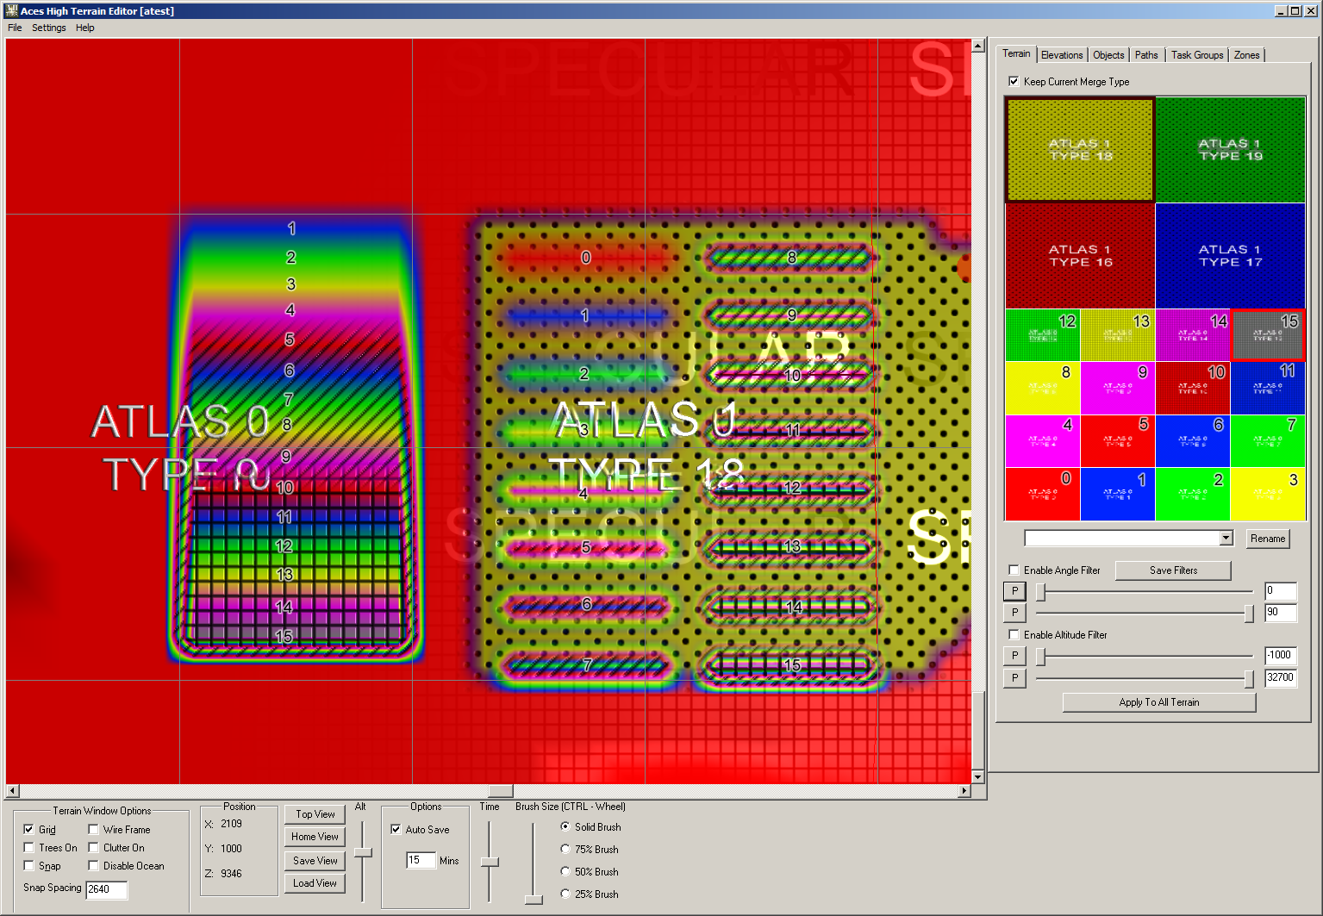
The Strict Folder Hierarchy:
There is a strict method in creating the tile set, which you must adhere to. To start with, if you want to create your own custom tile sets, you must adhere to a strict folder hierarchy. The highest level folder is normally the terrain folder, but it can be a placeholder so long as it exists. It may be necessary to include the defset.txt file inside this highest level folder. The second level folder must be the "terrset##" folder.
Create a folder named “terrset00”, in your terrain root folder. This is where all the magic will be done. The name of this folder can be one of three names, currently (terrset00, terrset01, or “ terrset02”). Let's start with “terrset00”.

The “terrset00” folder will be comprised of a “texsrc” folder (do not change that name!) and four text files named as follows:

The Atlas Text Files:
“atlas0.txt” and “atlas1.txt”
Contains the color and detail image information for the tile set plus a list of the bitmaps used by the terrain tile set.

“catlas0.txt” and “catlas1.txt”
Contains the clutter index information for the tile set plus a list of the bitmaps used for the high detail terrain features such as villages and cliff faces.

These file names must exist and be named exactly how they are listed. They are the required atlases needed to build a tile set.

Optionally, you can also have an “objdet.txt” and a “terrdet.txt” atlas text file as well.

Let's go through what each of these six files must contain and what you have to supply in order to build a custom tile set. You may want to open one of the supplied atlas files and follow along.

Atlas Headers:
The first five lines of any atlas text file will contain information in a "header", which must be provided exactly as follows:

Line 1: atlas

Just the one word. No leading, or trailing spaces.

Line 2: ###,ImageSize

Replace the “###” with the value from the provided chart below.
NOTE: The actual image size you create will be “508” and “1016' pixels in size. The remaining pixels are used to fill in between the textures of the terrain.

Line 3: #,ChannelCnt

The “#” needs to be replaced with the correct value. It tells the “Terrain Editor” how many color channels to use when building the texture. Use the value supplied in the chart below for the appropriate file you are creating.

Line 4: #,rows

This value represents the number of image rows, the atlas will contain. Use the value supplied in the chart below for the appropriate file you are creating.

Line 5: #,cols

This value represents the number of image columns, the atlas will contain. Use the value supplied in the chart below for the appropriate file you are creating.

Here is an example of the header for “atlas0.txt”.

atlas
512,ImageSize
4,ChannelCnt
4,rows
4,cols

After the five line header is a list of the images you will create for your tile set. They will all start with “texsrc/” as that is the directory where all the images you create will be stored.

The number of images is shown in the chart, for the appropriate text file you are creating.

Here is an example of the file name list for “atlas0.txt”. The actual names of the image files is up to you. The order is important. It is the order the “Terrain Editor” will use when blending from one image to another. When selecting a name for this list, remember all images will be stored in the same “texsrc” folder, so each image set, for each atlas, must have unique names.

texsrc/tile0.bmp
texsrc/tile1.bmp
texsrc/tile2.bmp
texsrc/tile3.bmp
texsrc/tile4.bmp
texsrc/tile5.bmp
texsrc/tile6.bmp
texsrc/tile7.bmp
texsrc/tile8.bmp
texsrc/tile9.bmp
texsrc/tile10.bmp
texsrc/tile11.bmp
texsrc/tile12.bmp
texsrc/tile13.bmp
texsrc/tile14.bmp
texsrc/tile15.bmp

The base name you supplied in the image list (i.e. “tile0” from “tile0.bmp””) will be the name you use for the actual images you create which are used to build the atlas. Each one of the images in the list is actually comprised of several images, all using the base name of the image from the list. Use the following chart to get the list of images you must create for each line item in the atlas list.

The following table contains the information you must supply with each atlas.
Assign bmp* | atlas0.txt | atlas1.txt | catlas0.txt | catlas1.txt | terrdet.txt | objdet.txt
Atlas Header
ImageSize | 512 | 1024 | 512 | 1024 | 512 | 512
ChannelCnt | 4 | 4 | 1 | 1 | 4 | 4
rows | 4 | 2 | 4 | 2 | 4 | 4
cols | 4 | 2 | 4 | 2 | 4 | 4
*Text assignments for mapping of particular ground or clutter/detail types to the color values.
Bitmaps | Image for ground |  | greyscale clutter assign |  | rock/mud | brick/asphalt
# of Images | 16 | 4 | 16 | 4 | 16 | 16
Image Size | 508 x 508 | 1016 x 1016 | 508 x 508 | 1016 x 1016 | 508 x 508 | 508 x 508
Image Type
Diffuse | Y (no ext) | Y (no ext) | N | N | N | N
Detail Type | Y (_a0) | Y (_a0) | N | N | N | N
Specular | Y (_b1) | Y (_b1) | N | N | Y (_a1) | Y (_a1)
Brightness | N | N | N | N | Y (_b1) | Y (_b1)
Normal Map | Y (_n) | Y (_n) | N | N | Y (_n) | Y (_n)
Clutter Index | N | N | Y (no ext) | Y (no ext) | N | N

NOTES: All images are of the bitmap file type.

Diffuse image ← 8 bit, indexed color Naming Convention: basename.bmp
This image contains the RGB color information for the texture. Use the base name you listed in the image list of the appropriate text file, for the name of this image.

Detail Type image ← 8 bit, greyscale Naming Convention: basename_a0.bmp
Each pixel of this image is used as an index value into your detail texture (terrdet atlas). The pixel values are multiples of sixteen, starting with zero. For instance, if the greyscale, for any given pixel, is 16, then this would would use the second detail texture, from the detail atlas (terrdet atlas). 32 would use the third detail texture and so on.
When naming this file, use the base name from the image file list of the appropriate text file and append “_a0” to the name.
SEE folder: path... terrset00\detail\objectdetail.

Specular image ← 8 bit, greyscale Naming Convention: basename_ + b1 or a1.bmp
Each pixel in this greyscale image is used to set the specular level. It ranges from 0 (black = flat) to 255 (shiny = white).
The naming convention will depend on the atlas you are working with. Use the table above, to select the correct extension to be added to the basename.

Normal map image ← 32 bit color Naming Convention: basename_n.bmp
This bitmap contains the normal map for this image. Normal maps contain information which allow for added details to be presented when the video card renders the terrain. Creating normal maps can be very time consuming. We have provided a couple of links to help with the process.

https://developer.nvidia.com/nvidia-texture-tools-adobe-photoshop
http://cpetry.github.io/NormalMap-Online/

The file naming convention for this image is to use the basename with “_n” appended to it.

Clutter Index image ← 8 bit, greyscale Naming Convention: basenameclutter.bmp
This image contains an index value used to insert something into the tile. For clutter, each pixel of this bitmap is used as an index value into the list of clutter, in the terrain editor. The pixel values are multiples of sixteen, starting with 16 (zero means “no clutter”). For instance, if the greyscale, for any given pixel, is 16, then this would use the second clutter object, from the terrain editor.
SEE folder: path... terrset00\detail\terraindetail.

Once you have created the images for each tile set, you can then move to adding trees. To add trees, you would use the “Object Editor” to place trees from the existing resource databases for the object editor. You cannot create trees. You can only use what is supplied with the “Object Editor”.

Trees are placed using the Object Editor. It creates an swa (text) file, however, the OE doesn't build the terrain type files. That's done in the Terrain Editor the next time you build your terrain. You won't see the trees in the TE until you build and reload the terrain and then turn on the Trees checkbox.
For further information and to place the trees, consult the “Object Editor” manual.

ORIGINAL TEXT descriptions of the Atlas

So what goes into a terrain tile?

Each individual terrain type/tile must have these files:
A diffuse map, normal map, specular map, detail map, a clutter map and a speedtree map.

ALSO, SIZE IS VERY IMPORTANT!! - For the 16 type atlases (ATLAS0, CATLAS0) as well as the detail atlases (OBJDET, TERRDET) – 508 pixels x 508 pixels must be used! For the Large Atlas (ATLAS1) 1016 pixels by 1016 pixels must be used.

Creating tiles requires familiarity with a layer-based graphics program like Photoshop, Paintshop Pro or Gimp. The files are worked on in the program's native multi-layer format (i.e. psd for Photoshop) and only saved as a bmp for viewing in the TE or game.

So lets work on a terrain type that will go into an atlas for this example we'll call it “grassyrock”.

Diffuse: 508x508 8 bit 256 color BMP. “Grassyrock.bmp”
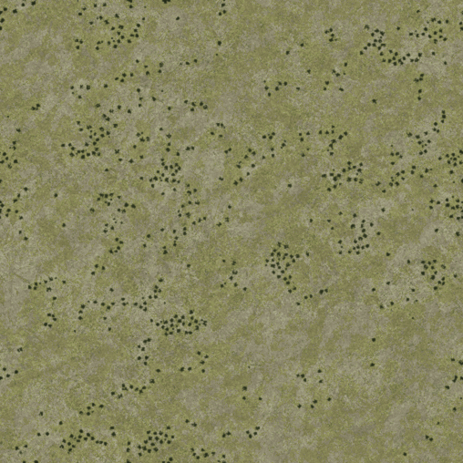
Normal: 508x508 32 bit BMP. “Grassyrock_n.bmp”
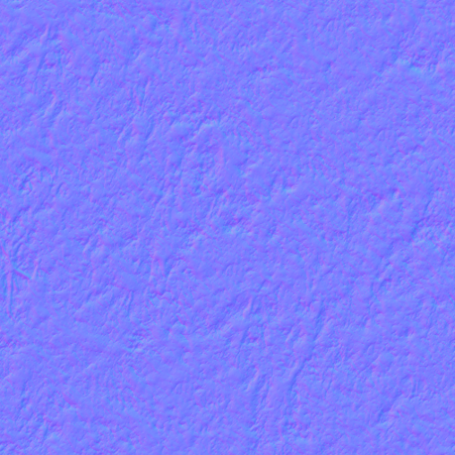
Specular: 8 bit greyscale BMP “Grassyrock_b1.bmp”

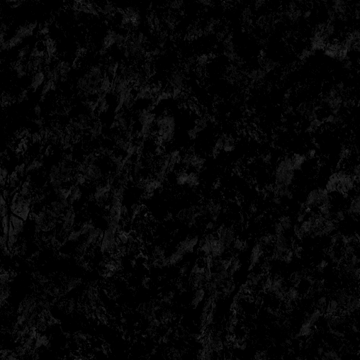

Detail Map: 8 bit greyscale BMP “Grassyrock_a0.bmp”

Clutter Map: 8 bit greyscale BMP “Grassyrockclutter.bmp”

These are the images that create each terrain type. YOU MUST append the diffuse name with an “_n”, “_b1”,”_a0” for the atlas maker to work correctly. For clutter, you can just add “clutter” to the filename.

Diffuse Map: The diffuse map is created first. This essentially a painting of the terrain that is draped across the contours of the ground. When painting the diffuse map its a good idea to assign each material type its own layer so you can quickly copy and paste these areas to the other maps later on rather than having to paint them again.

Normal Map Creation: A normal map uses the rgb colors of an image to represent an X Y Z unit vector. This vector is used to light objects as if there was a surface who's normal would be this unit vector. Put another way the normal map allows the game to simulate bumps and dips on the surface of the terrain by creating shadows and highlights derived from both the position of the sun and the angle of the terrain surface relative to the sun. This link shows the effect:-

http://cpetry.github.io/NormalMap-Online/

The normal map is created in two stages and the first stage is to create a bump map. This bump map is a 16 bit or higher grayscale image with lighter shades of gray representing the higher areas in the terrain and darker shades lower areas.
So for our grassy rock tile the bump map would have the rocky areas painted lighter than the grassy areas to make them appear to stand higher than the more easily weathered soil. The rocky areas are also broken up with a scattering of lighter and darker pixels to give it a rougher look than the surrounding soil.
Once the bump map is ready it has to be converted into a normal map and this requires normal-generating software. Some normal software is stand-alone and some can be linked to your graphics program as a plug-in. The process for linking a plug-in should be described in your graphics program's help file.
Nvidia make a free normal-generating plug-in that works with either Photoshop or Paintshop Pro and can be found here:-

https://developer.nvidia.com/nvidia-texture-tools-adobe-photoshop

There is also a free plug-in made for Gimp which can be found here:-

http://registry.gimp.org/node/69

To make the normal map first load your bump map bmp file into the normal software, or into your graphics program if using a plug-in. Once activated the normal software will bring up a window giving numerous display options. On the Nvidia plug-in that I use the only settings I alter from default are "Invert Y" and "Scale". Invert Y changes the look of the normal file so that it appears light is coming from the top rather than from the bottom of the image and this makes the resultant normal image a lot easier to understand. Scale alters the size of the bumps, a bigger number means bigger bumps. You can also alter the bump sizes by using more or less extreme shades of gray on your original bump map but generally it is better to use the scale setting.
The normal map appears as a violet 3D image with lit and shaded areas indicating variations in height. For our grassyrock tile the rocky areas have more extreme variations than the flatter grassy areas.

Specular Map: The specular map defines how well each part of your texture reflects the sun's rays.
So for instance you might have a light shade of gray on the specular map in the same place as an icy area on your diffuse map, a medium shade where there is a tarmac road and a dark shade for earthen areas. The resultant reflective differences between surface types can create a powerful illusion of reality in the game.
For our grassy rock texture the rocky areas are a little lighter than the grassy areas and so will reflect more brightly.

A good thing to keep in mind during this step is the blending of the textures in game. A good rule of thumb is to lay out your textures from the lowest elevation textures to the highest. The reason for this is that you want to avoid having a lower indexed texture slot (0) blending with a higher indexed texture slot (16).
This can produce anomalies and oddities such a lines around terrain types, ect...

A second issue in building the diffuse textures are graphic additions for roads, dry streams beds, wind rows of trees etc. When two tiles are placed beside each other, or blending in the middle, these painted graphic details may not align.

Yet one last issue affecting tile textures in the past was incompatible indexed color tables. The textures might have completely different color index tables and the two would clash. Most often however, this appeared only for custom square tile object textures overlaying the diffuse terrain texture below. Although the current game engine handles this transparently, it should usually be verified.

The Detail Map and the Clutter Map work together:
Both are grayscale bitmaps.
Each pixel in the Detail bitmap, identified by the _a0.bmp extension, identifies a particular high definition texture such as a plowed field or rock.
By convention, the Clutter bitmap is identified by its name (basename +)clutter.bmp extension, such as type3clutter.bmp. Each pixel in the bitmap identifies a particular class of ground clutter such as corn stalks or bamboo.
Each pixel will have an incremented index value ranging from 0 to 255 in increments of 16. The pixels' gray in the grayscale bitmap will be visually different.

The default terrset00 terrain detail for terrain tiles
..\detail\terraindetail\sandsnow.bmp
..\detail\terraindetail\mud.bmp
..\detail\terraindetail\cracked.bmp
..\detail\terraindetail\dirtroad.bmp
..\detail\terraindetail\grassrock1.bmp
..\detail\terraindetail\grassrock2.bmp
..\detail\terraindetail\grass1.bmp
..\detail\terraindetail\grass2.bmp
..\detail\terraindetail\moss.bmp
..\detail\terraindetail\leaves.bmp
..\detail\terraindetail\ivy.bmp
..\detail\terraindetail\gravel.bmp
..\detail\terraindetail\rock1.bmp
..\detail\terraindetail\farm1.bmp
..\detail\terraindetail\farm2.bmp
..\detail\terraindetail\noise.bmp

terrdet.txt lists the 16 high detail bitmaps to be used in the terrain

Find the terraindetail folder, follow htcterrsets\detail\terraindetail.

Please Note: The Detail text files that currently ship include HTC's File Paths and although they can be anywhere on your harddirve, it's best to store them with each terrain and modify the file paths appropriately.

Detail Map: This greyscale image tells the game where to draw detail textures from the TERRDET atlas. RGB 0 is the first detail type, rgb 16 is the second, rgb 32 is the third, ect.... on the corresponding TERRDET atlas
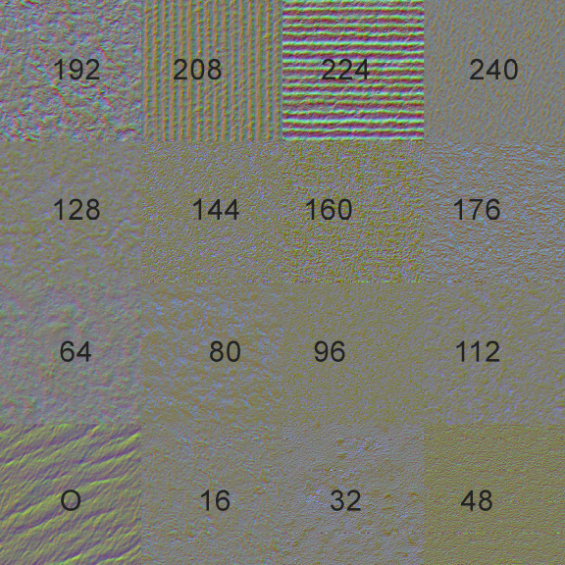
The default terrset00 object detail for sq tiles
00..\detail\objectdetail\asphalt01.bmp
16..\detail\objectdetail\asphalt03.bmp
32..\detail\objectdetail\concrete01.bmp
48..\detail\objectdetail\concrete02.bmp
64..\detail\objectdetail\3secconcrete.bmp
80..\detail\objectdetail\4secconcrete.bmp
96..\detail\objectdetail\grass1obj.bmp
112..\detail\objectdetail\dirt02.bmp
128..\detail\objectdetail\gravel01.bmp
144..\detail\objectdetail\rocks.bmp
160..\detail\objectdetail\grassrock2.bmp
176..\detail\objectdetail\brick05.bmp
192..\detail\objectdetail\brick02.bmp
208..\detail\objectdetail\dirtroad.bmp
224..\detail\objectdetail\concrete04.bmp
240..\detail\objectdetail\dirtroad.bmp

You can also create your own detail atlas for use in your terrain. It is built very similar to the main atlases. We will cover that later.
Clutter Texture – This greyscale texture tells the game where and what type of grass, and clutter to draw. Like the detail map, it too is divided by RGB 16 values. RGB 0 = first type of clutter, rgb 16 = second type, ect.... This is modifiable by the user by the clutter definition file, which the user can assign a particular clutter type to an RGB Value.

Speedtree map - Finally, Add trees, bushes and buildings to a terrain type tile in the Object Editor (OE). It creates the speedtree swa file.

Editing Terrains with L3DT Pro

(www.bundysoft.com/L3DT/)

To edit height fields in L3DT pro, Open your converted terrain and click "export" in the AH terrain editor. It will create a file called "height.raw" in your converted terrain folder. This will be the file that gets imported into L3DT to edit the height.

Getting the "height.raw" file into L3DT:
-Open L3dt Pro and select "File > Import > Height field" and point it towards the "height.raw" file.
-Enter "660" in the Horizontal Scale data box. Click "OK"
-Enter "4096" for both the Width and Height
-Set mode to "16-bit signed" with the "Invert Y Axis" check box checked. Click "OK"

Now you can edit the height field within the L3DT program.

Getting your Height field from L3DT back into Aces High
-Choose "File > Export > active map layer"
-Select "Raw" as your File format and select the directory where you want to export it.
-Click the option button and set mode to "16-bit Signed (manual scale)" and "Invert Y" to "true"
-Export the Raw file and name it "newheight.raw and place in your working terrain folder. -Open the AH editor and Click on "File > import signed height map" to import the new height map

NOTE: L3dT uses meters as their stand elevation units, but using the above setting, the meter display in L3DT will be feet in Aces High.

THE OBJECT EDITOR

THIS WRITEUP IS SUBJECT TO CHANGE.

The Object Editor (OE) has three functions:
1. Add trees, bushes and buildings to a terrain type tile.
2. Create "Square Tile Object" such as airfield, towns and factories.
3. Facilitate The creation of custom objects such as new buildings, runways and other useful objects.

Add trees, bushes and buildings to a terrain type tile, a Speedtree file.

THIS WRITEUP IS SUBJECT TO CHANGE.

Definitions:
terr set - Terrain tile texture set including all the textures, atlases, folder etc. needed to define the set.

Each individual terrain type/tile must have these files:
A diffuse map, normal map, specular map, detail map, a clutter map and a speedtree swa file.

A terrain "tile" can not be created without a terrain texture. Creating terrain type texture is discussed here. If you don't have a custom terrain texture, HTC has shipped the default terrain sets that can be used for experimentation. They can be found in the following folders:
htcterrsets folder - samples and the default terrain textures for the game.
C:\Hitech Creations\Aces High Alpha Game\ah3terr\tiles\htcterrsets
terrset00 (Europe Summer)
terrset01 (Pacific Summer)
terrset02 (WWI Europe Summer)
terrset03 (Mediterranean/Desert)

In addition, a very educational preassembled set was shipped with the Alpha as terrset00. This set is composed of textures with the Atlas # and Type # of each terrain type texture.

Before the OE can do anything with a terrain type tile, it must have a preexisting folder hierarchy to work. Currently, that includes a preexisting terrain project. The hierarchy is as follows:

C:\Hitech Creations\Aces High Alpha Game\ah3terr\[myterrain]\terrset##\

[myterrain] is the name of a terrain, but it can be a dummy, as in a folder with nothing inside except the terr set folders.

terrset## (terr set for short) is a folder to hold all the files for a particular terr set. The numbers are zero zero to ...##.

Normally, each terr set folder will contain only the proper subfolders, atlases and other files for that particular terr set.
However, since this is for experimentation, for each terrset## folder, simply drop the entire content of the htcterrsets folder into each terrset## folder such that the new hierarchy matches as follows.

[myterrain]
terrset00
508
1016
atlasterrset00
atlasterrset01
atlasterrset02
detail
spdtree
terrset01
508
1016
atlasterrset00
atlasterrset01
atlasterrset02
detail
etc.

This will allow almost unrestricted access to the entire library.

In practice, for a real terrain, you would separate the different terr set components appropriately, using only those atlases and textures necessary for each terr set. To do otherwise is to invite disaster.

Launch the Object Editor.
The terr set number code must match the terr set name in the OE's Properties dialog box.
folder Properties "Active tile set"
terrset00 Europe Summer
terrset01 Pacific Summer
terrset02 WWI Europe Summer
terrset03 Mediterranean/Desert

Failure to set the Properties, or an incorrect folder hierarchy will result in an error:
"You must first select the terrain set that matches this set."

Once you set the correct Properties in the OE, you may open the terrain type texture.
Select File>Open Terrain Tile. Then browse to one of the diffuse bitmaps. A diffuse bitmap is NOT a bitmap with an underscore in the name, or one with "clutter" in the name.

If this still fails, open Properties again, and in Display Textures, Browse to any of the appropriate diffuse bitmaps and select it to open it. Click OK. This is probably an error that will be corrected. Continue with the next step.

Open one of the diffuse bitmaps.

Notice that the list of objects that can be included is relatively limited compared to creation of Square Tile objects. This is because only HTC default "Speed Tree" objects are allowed in a terr sets and because only those object appropriate to the terr set selected in the Properties are shown.

Next, set the grid check box. Notice that the texture covers much more then the 1x1 mile grid. Each terrain texture covers two miles by two miles.

Add a tree somewhere inside the boundary of the terrain texture and save.
Select the tree type from the “Shapes” drop down list.
Then left click the selected place on the texture, for the tree and “Add” it.
When Saved, it will create a new set of files and directories(?) in your terr set folder...\spdtree\swa folder matching the name of the terrain texture with a .swa file extension. It's format is very similar to the .obj file format.

When the TE eventually builds a terrain with these new terr sets, additional folders and binary versions of the terr sets are created.
Do not move these files or folders, as the terrain and object editor depend on the location being where they are.

In a terrain to be uploaded, the following folder hierarchy is recommended:

[myterrain]
texsrc folder with the CBM
terrset00 folder
texsrc folder with all the textures for this terr set, both 508 and 1016
atlasterrset00
detail
spdtree
terrset01 folder
texsrc folder with all the textures for this terr set, both 508 and 1016
atlasterrset01
detail
spdtree
etc.
myterrain.oba file
other TE files

Create "Square Tile Object"

The creation of custom objects

